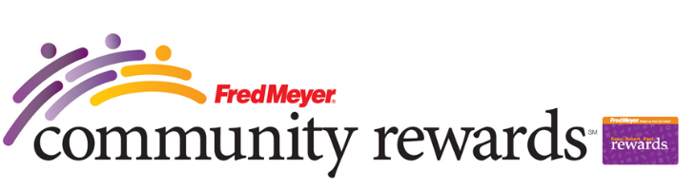
Fred Meyer Step-by-Step Instructions!
If you like shopping at FRED MEYER you can easy help Sunny Hills PTA to earn money without spending a penny and you’ll still earn YOUR OWN Rewards Points, Fuel Points and Rebates. Please just follow the steps below:
Step 1: Sign up for a Rewards Card at the Fred Meyer Customer Service Desk or at any Cashier next time you shop. If you already have Fred Meyer Rewards Card you can begin from Step 2. Step 2: Visit Fred Meyer's Community Rewards page and log into (or create) your online account. Step 3: On this page under the section called “Are you a Fred Meyer Customer?” find and click “Re-enroll or link your Rewards Card now” and enter your personal information on request. Step 4: Search Sunny Hills by name or by our nonprofit number (91256). Click ENROLL to complete. Now you will see Sunny Hills in your Profile under Community Rewards. Step 5: Every time you shop at Fred Meyer, use your Rewards Card. Sunny Hills will earn a donation with each transaction!
NOTE: If you already linked your Fred Meyer card with Sunny Hills previous year(s) you do not need to do it again this year or update anything!

Thanks for your time and for your efforts!
If you have any questions about our programs please contact Julia Ignatova jignatova9@hotmail.com

